Voltage Multiplier

The voltage multiplier is an electronic circuit that delivers the output voltage whose amplitude (peak value) is two, three, or more times greater than the amplitude (peak value) of the input voltage.

The voltage multiplier is an AC-to-DC converter, made up of diodes and capacitors that produce a high voltage DC output from a low voltage AC input.

Types of voltage multipliers

Voltage multipliers are classified into four types:

1. Half-wave voltage doubler
2. Full-wave voltage doubler
3. Voltage tripler
4. Voltage quadrupler

Half-wave voltage doubler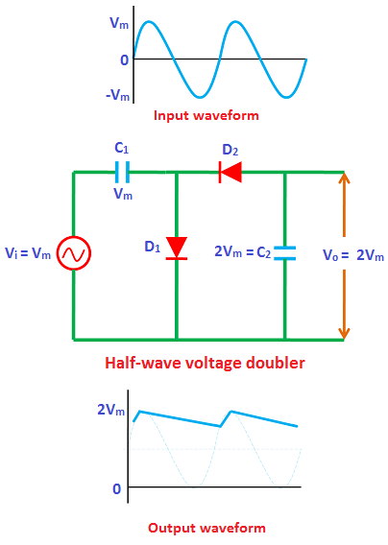

During positive half cycle:

The circuit diagram of the half-wave voltage doubler is shown in the above figure. During the positive half cycle, diode D1 is forward biased. So it allows electric current through it. This current will flows to the capacitor C1 and charges it to the peak value of input voltage I.e. Vm.

However, current does not flow to the capacitor C2 because the diode D2 is reverse biased. So the diode D2 blocks the electric current flowing towards the capacitor C2. Therefore, during the positive half cycle, capacitor C1 is charged whereas capacitor C2 is uncharged.

During negative half cycle:

During the negative half cycle, diode D1 is reverse biased. So the diode D1 will not allow electric current through it. Therefore, during the negative half cycle, the capacitor C1 will not be charged. However, the charge (Vm) stored in the capacitor C1 is discharged (released).

The diode D2 is forward biased during the negative half cycle. So the diode D2 allows electric current through it. This current will flows to the capacitor C2 and charges it. The capacitor C2 charges to a value 2Vm because the input voltage Vm and capacitor C1 voltage Vm is added to the capacitor C2. Hence, during the negative half cycle, the capacitor C2 is charged by both input supply voltage Vm and capacitor C1 voltage Vm. Therefore, the capacitor C2 is charged to 2Vm.

Full-wave voltage doubler

The full-wave voltage doubler consists of two diodes, two capacitors, and input AC voltage source.

During positive half cycle:

During the positive half cycle of the input AC signal, diode D1 is forward biased. So the diode D1 allows electric current through it. This current will flows to the capacitor C1 and charges it to the peak value of input voltage , Vm.

Diode D2 is reverse biased during the positive half cycle. So the diode D2 does not allow electric current through it. Therefore, the capacitor C2 is uncharged.

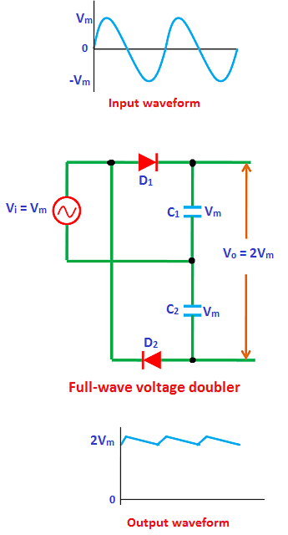

During negative half cycle:

During the negative half cycle, diode D2 is forward biased whereas diodes D1 and D3 are reverse biased. Hence, the diode D2 allows electric current through it. This current will flows to the capacitor C2 and charges it. The capacitor C2is charged to twice the peak voltage of the input signal (2Vm). This is because the charge (Vm) stored in the capacitor C1 is discharged during the negative half cycle.

Therefore, the capacitor C1 voltage (Vm) and the input voltage (Vm) is added to the capacitor C2 I.e Capacitor voltage + input voltage = Vm + Vm = 2Vm. As a result, the capacitor C2 charges to 2Vm.

During second positive half cycle:

During the second positive half cycle, the diode D3 is forward biased whereas diodes D1 and D2 are reverse biased. Diode D1 is reverse biased because the voltage at X is negative due to charged voltage Vm, across C1and diode D2 is reverse biased because of its orientation. As a result, the voltage (2Vm) across capacitor C2 is discharged. This charge will flow to the capacitor C3 and charges it to the same voltage 2Vm.

The capacitors C1 and C3 are in series and the output voltage is taken across the two series connected capacitors C1 and C3. The voltage across capacitor C1 is Vm and capacitor C3 is 2Vm. So the total output voltage is equal to the sum of capacitor C1 voltage and capacitor C3 voltage I.e. C1 + C3 = Vm + 2Vm = 3Vm.

Therefore, the total output voltage obtained in voltage tripler is 3Vm which is three times more than the applied input voltage.

Voltage Quadrupler

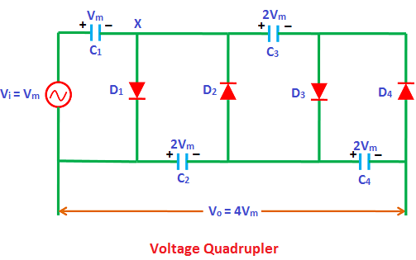

The voltage quadrupler can be obtained by adding one more diode-capacitor stage to the voltage tripler circuit.

During first positive half cycle:

During the first positive half cycle of the input AC signal, the diode D1 is forward biased whereas diodes D2, D3 and D4 are reverse biased. Hence, the diode D1 allows electric current through it. This current will flows to the capacitor C1 and charges it to the peak value of the input voltage I.e. Vm.

During first negative half cycle:

During the first negative half cycle, diode D2 is forward biased and diodes D1, D3 and D4 are reverse biased. Hence, the diode D2 allows electric current through it. This current will flows to the capacitor C2 and charges it. The capacitor C2is charged to twice the peak voltage of the input signal (2Vm). This is because the charge (Vm) stored in the capacitor C1 is discharged during the negative half cycle.

Therefore, the capacitor C1 voltage (Vm) and the input voltage (Vm) is added to the capacitor C2 I.e Capacitor voltage + input voltage = Vm + Vm = 2Vm. As a result, the capacitor C2 charges to 2Vm.

During second positive half cycle:

During the second positive half cycle, the diode D3 is forward biased and diodes D1, D2 and D4 are reverse biased. Diode D1 is reverse biased because the voltage at X is negative due to charged voltage Vm, across C1 and, diode D2 and D4are reverse biased because of their orientation. As a result, the voltage (2Vm) across capacitor C2 is discharged. This charge will flow to the capacitor C3 and charges it to the same voltage 2Vm.

During second negative half cycle:

During the second negative half cycle, diodes D2 and D4 are forward biased whereas diodes D1 and D3 are reverse biased. As a result, the charge (2Vm) stored in the capacitor C3 is discharged. This charge will flow to the capacitor C4 and charges it to the same voltage (2Vm).

The capacitors C2 and C4 are in series and the output voltage is taken across the two series connected capacitors C2 and C4. The voltage across capacitor C2 is 2Vm and capacitor C4 is 2Vm. So the total output voltage is equal to the sum of capacitor C2 voltage and capacitor C4 voltage I.e. C2 + C4 = 2Vm + 2Vm = 4Vm.

Applications of voltage multipliers

Voltage multipliers are used in:

* Cathode Ray Tubes (CRTs)
* Traveling wave tubes
* Laser systems
* X-ray systems
* LCD backlighting
* hv power supplies
* Power supplies
* Oscilloscopes
* Particle accelerators
* Ion pumps
* Copy machines